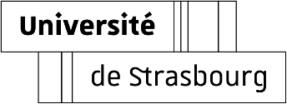





**ie**

L. Durieux

Abstract

This tutorial details the step-by-step assembly of the FPGA – Analog Board enclosure, including board installation, wiring of potentiometers, XLR output, and FTDI cable, followed by final enclosure assembly. Clear instructions ensure correct alignment, secure connections, and a clean final build.

FPGA & ANALOG Board Enclosure Assembly Tutorial

English – v1.0

Table of Contents

Section 1 — FPGA Board 2

1.1 Remove Factory Standoffs and Plastic Cover 2

1.2 Reuse 4 Standoffs Under the Board 2

1.3 Insert the FPGA into the 3D-Printed Base 2

1.4 Screw the Board into Place 3

1.5 Connect the Analog Daughterboard 3

Section 2 — Potentiometers 4

2.1 Cut and Prepare Wires 4

2.2 Strip and Pre-Tin the Wires 4

2.3 Solder Wires to Potentiometers 4

2.4 Crimp and Insert JST Connectors 5

2.5 Connect to Analog Board Headers 5

Section 3 — XLR Output 6

3.1 Use a 3-Pin XLR Male Connector 6

3.2 Solder Wires to the XLR Pins 6

3.3 Mount the XLR Connector in the Rear Panel 7

Section 4 — FTDI Cable 7

4.1 Cut and Strip the FTDI Cable 7

4.2 Crimp Contacts and Insert into Keyed Connector 8

4.3 Plug into J12 Header on Analog Board 8

Section 5 — Final Assembly 9

5.1 Insert All Connectors and Cables Neatly 9

5.2 Attach Front and Rear Panels 9

5.3 Add the Top Lid and Knobs 9

License Information 10

Versioning 11

# Section 1 — FPGA Board

## 1.1 Remove Factory Standoffs and Plastic Cover

Start by unscrewing the default metal standoffs and removing any plastic film or protective elements on top of the FPGA board. These are not compatible with our custom 3D-printed enclosure and analog signal board.

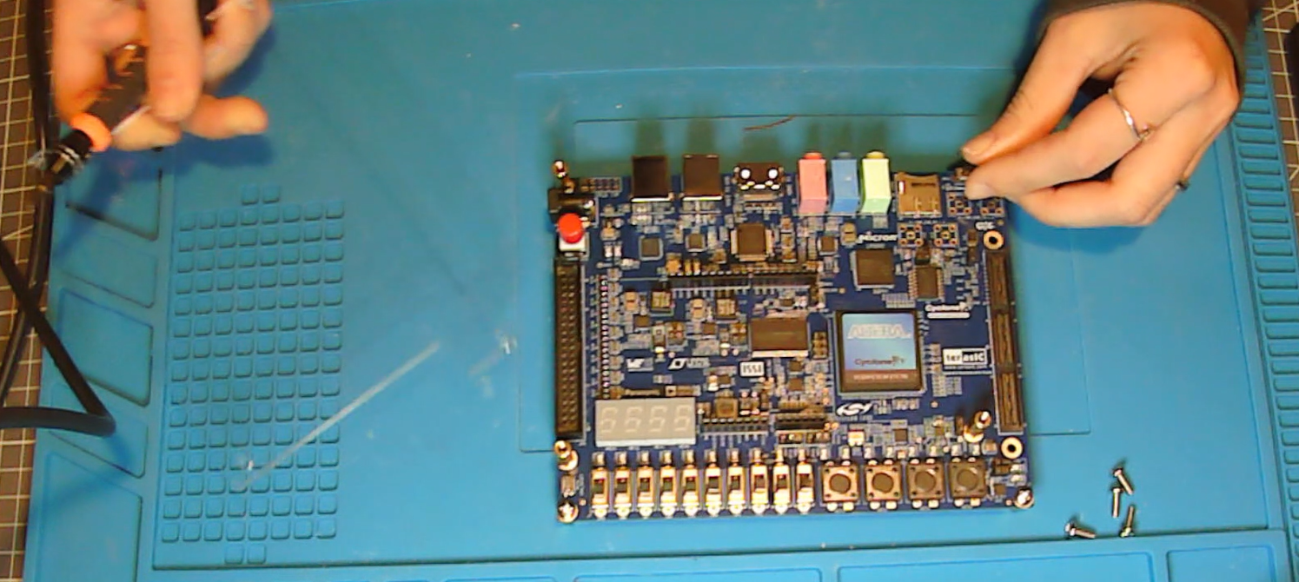

## 1.2 Reuse 4 Standoffs Under the Board

Keep only four of the original standoffs and screw them underneath the board in each corner. All other standoffs can be discarded or stored away.

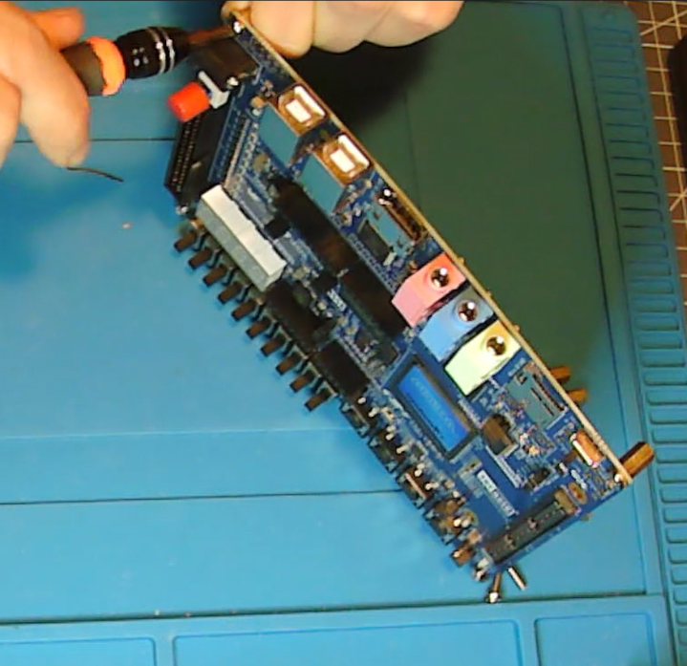

## 1.3 Insert the FPGA into the 3D-Printed Base

Carefully position the FPGA board into the 3D-printed enclosure. Make sure that the USB ports and power connector align properly with the cutouts in the enclosure walls.

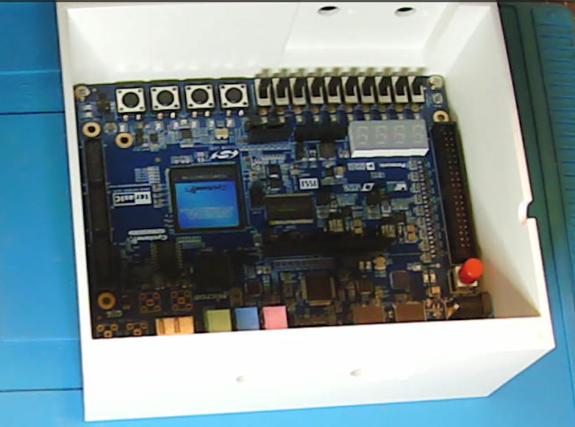

## 1.4 Screw the Board into Place

Use M3x5 screws to attach the board to the 3D-printed base via the four standoffs. Ensure the board sits flat and firm inside the enclosure.

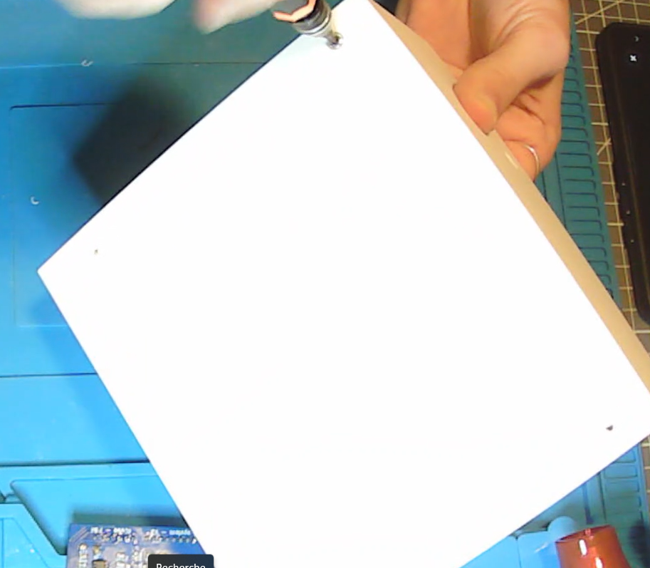

## 1.5 Connect the Analog Daughterboard

Install the analog PCB onto the FPGA by aligning the headers. The board fits in only one orientation. Press it down firmly until all pins are seated.

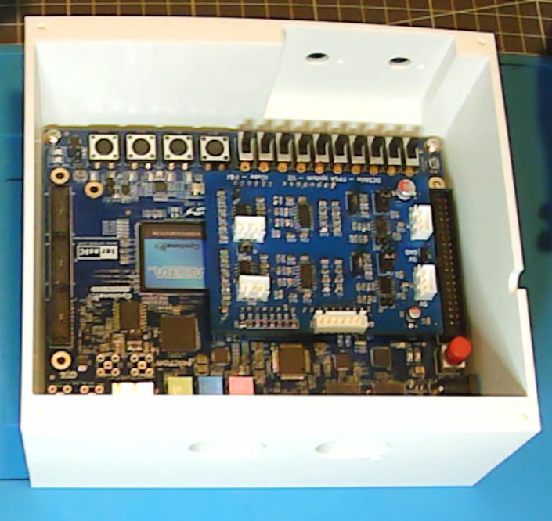

# Section 2 — Potentiometers

## 2.1 Cut and Prepare Wires

Cut 6 wires total: 2 orange (signal), 4 white (power and ground). For the upper channel (channel 1), use 15 cm wires. For the lower one (channel 2), 10 cm wires are enough.

## 2.2 Strip and Pre-Tin the Wires

Strip approximately 1 cm of insulation from one end of each wire for soldering. Optionally tin the ends with a bit of solder for ease of assembly.

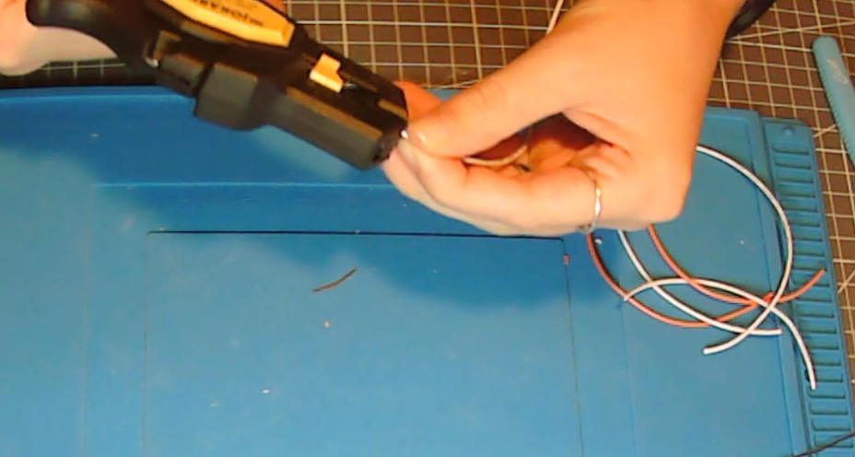

## 2.3 Solder Wires to Potentiometers

Thread each wire through the small holes in the potentiometer terminals. Wrap the exposed copper around the pin and solder it. The recommended order from left to right (facing the shaft) is: orange (input signal), white (output signal), white (output signal).

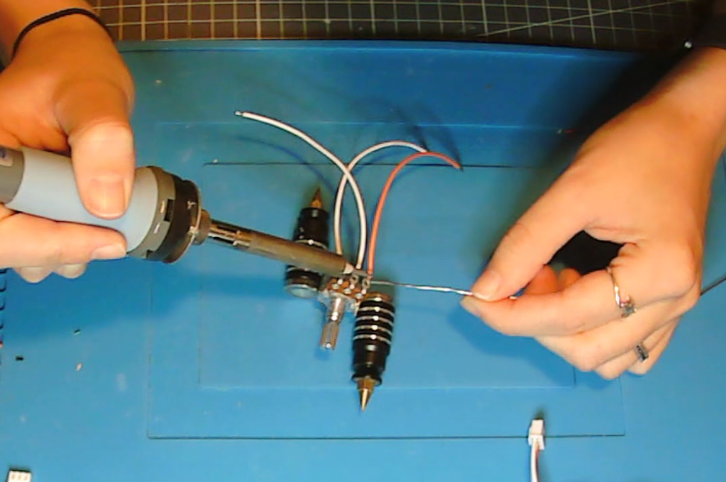

## 2.4 Crimp and Insert JST Connectors

On the other end of each wire, strip 2–3 mm and crimp JST contacts. Insert the contacts into a 3-pin JST housing. Make sure the orange signal wire goes to the correct slot (typically pin 1). The final order can be seen in the next part. Use heat shrink tubing if desired to bundle the wires.

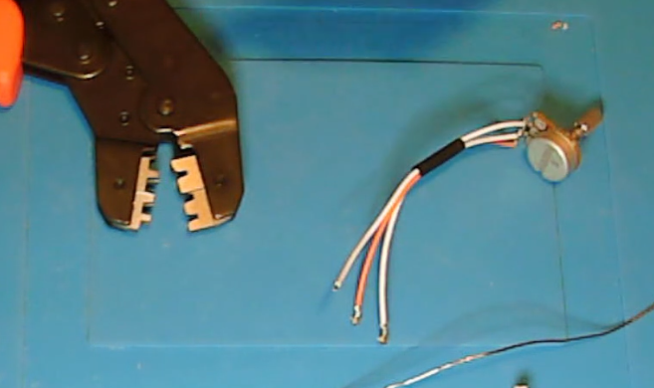

## 2.5 Connect to Analog Board Headers

Plug each 3-pin JST connector into the matching header on the analog board. Ensure the upper potentiometer (15 cm wires) connects to the upper header.

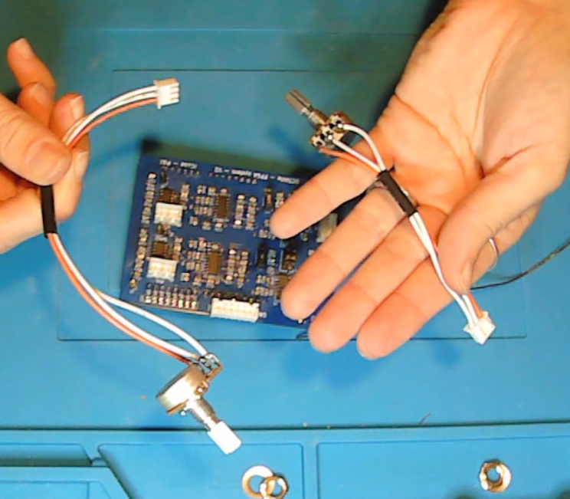

# Section 3 — XLR Output

## 3.1 Use a 3-Pin XLR Male Connector

We use a standard 3-pin XLR male connector to carry the analog output. Prepare three wires of about 20 cm each in distinct colors (e.g., red, black, green).

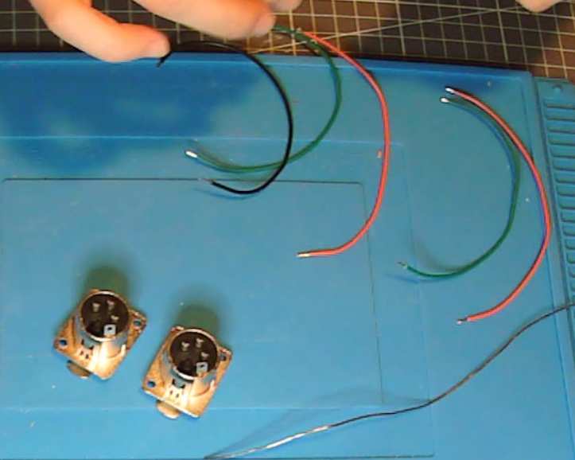

## 3.2 Solder Wires to the XLR Pins

Solder the wires to the XLR pins according to the standard: Pin 1 = GND, Pin 2 = Signal, Pin 3 = VDD. Make sure your analog board output header matches this logic. Be careful to follow the order of the cabling since the microphone is not protected. A wrong cabling could lead to its destruction.

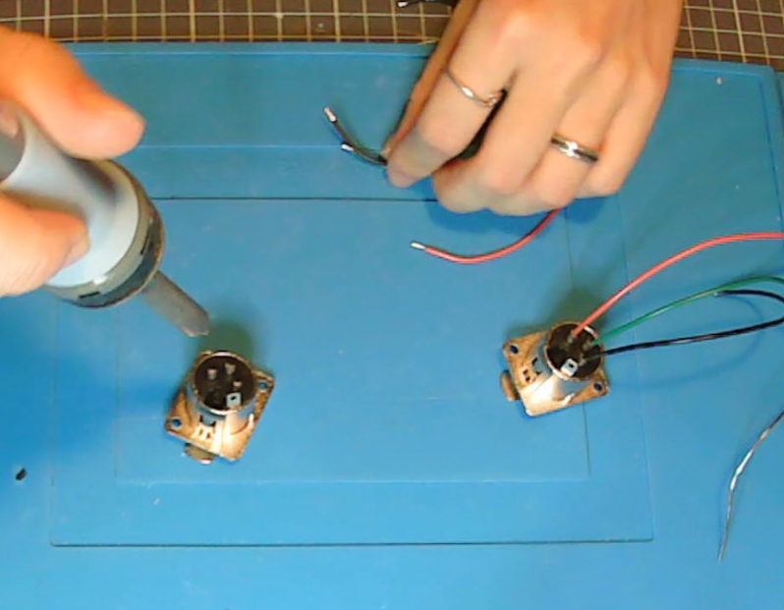

## 3.3 Mount the XLR Connector in the Rear Panel

Connect the XLR Wires to the Analog Board

Attach the wires to the analog board output header via a 3-pin JST. Double-check signal integrity and pin order.

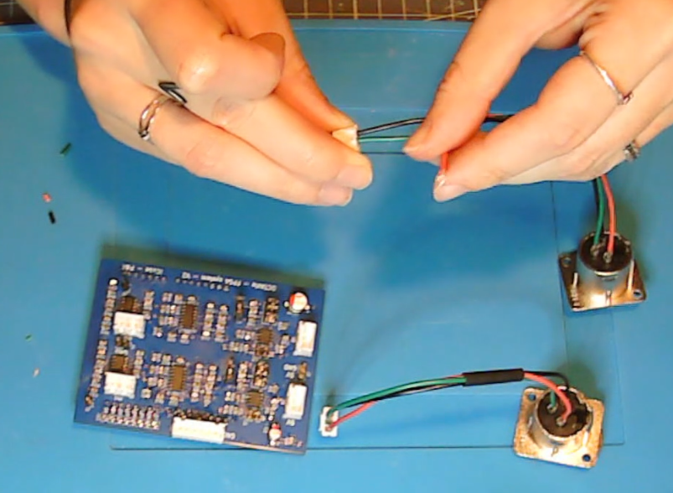

# Section 4 — FTDI Cable

## 4.1 Cut and Strip the FTDI Cable

Cut the FTDI cable to desired length (nearer of the header as possible to keep a maximum length is a comfortable solution). Strip all six wires.

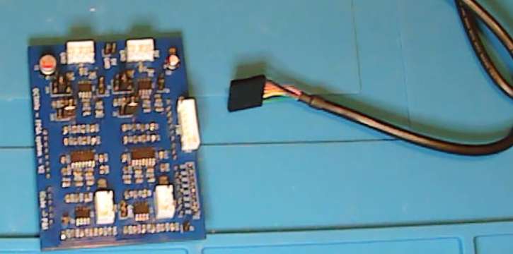 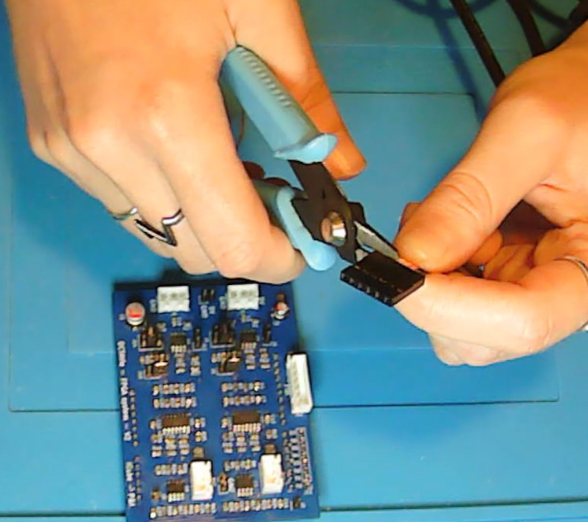

## 4.2 Crimp Contacts and Insert into Keyed Connector

Crimp each wire into a JST contact and insert them into a 6-pin keyed JST housing in the following order starting from GND, written on the PCB board: Black, Brown, Red, Orange, Yellow, Green.

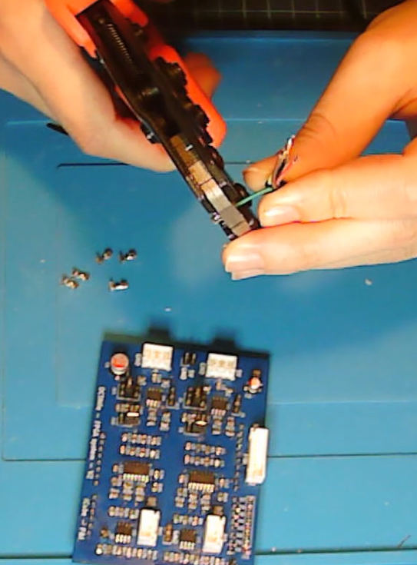 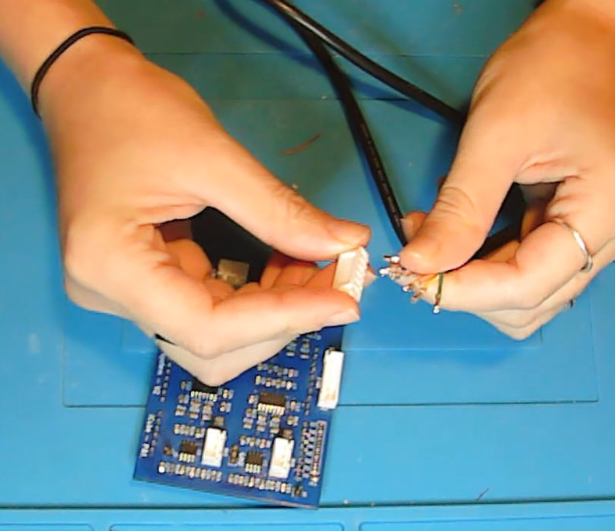

## 4.3 Plug into J12 Header on Analog Board

Insert the keyed connector into J12 on the analog board. The notch ensures correct polarity.

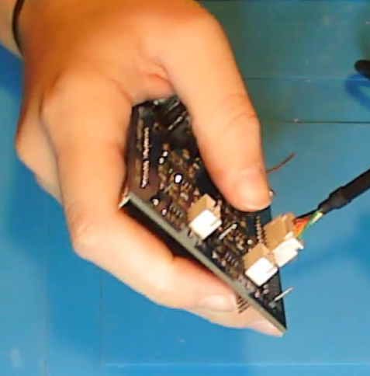

# Section 5 — Final Assembly

## 5.1 Insert All Connectors and Cables Neatly

Make sure all JST cables are connected securely. Route cables neatly so that they do not interfere with the enclosure lid.

## 5.2 Attach Front and Rear Panels

Screw the front and rear panels into the 3D-printed base. Align all cutouts and components properly.

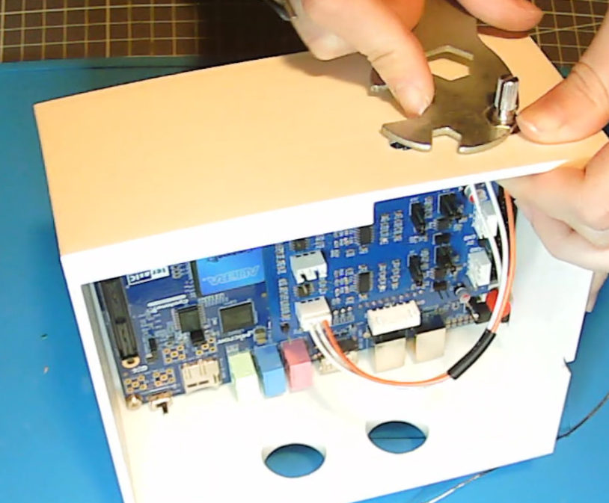 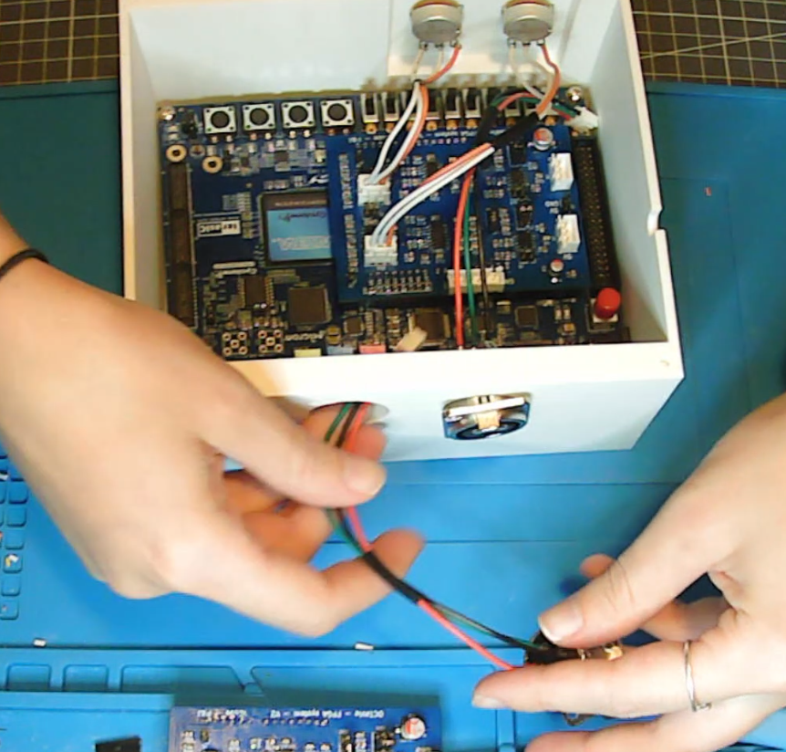

## 5.3 Add the Top Lid and Knobs

Use the M3x5 screws to secure the top lid. Install plastic caps on the potentiometer shafts and mark the channels if needed.

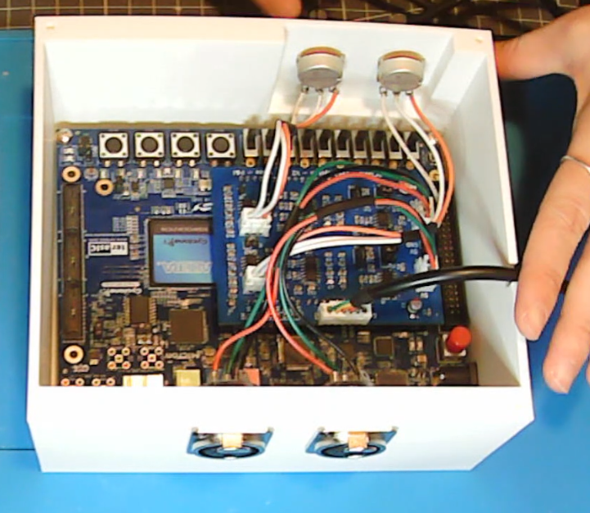 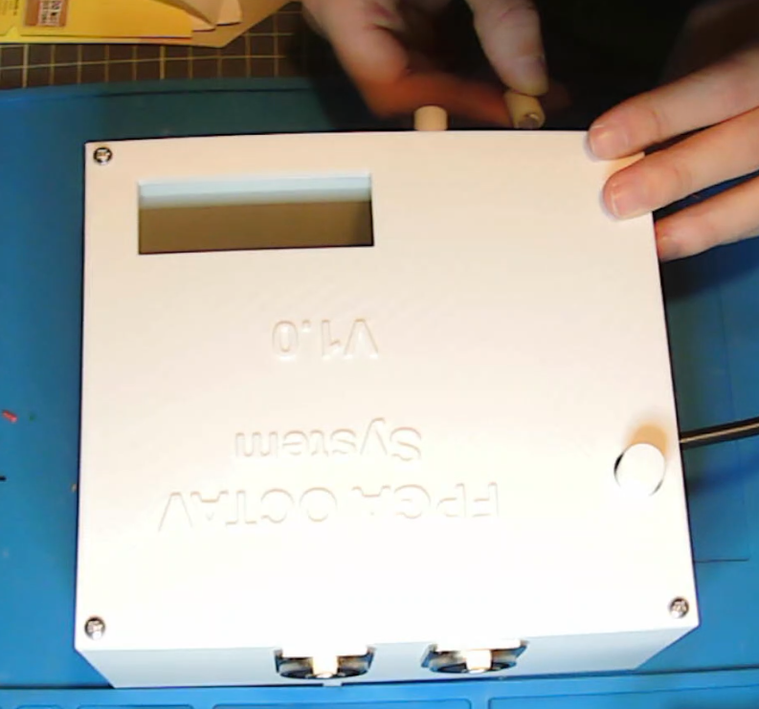

# License Information

**Hardware license**: CERN Open Hardware License v2 (Strongly Reciprocal – OHL-S).

**Software license**: GNU General Public License v3 (GPLv3), ensuring that all modifications remain open-source.

**Documentation license**: Creative Commons Attribution-ShareAlike 4.0 International (CC-BY-SA 4.0).

# Versioning

|  |  |  |  |
| --- | --- | --- | --- |
| Authors | Version | Date | Comment |
| L. Durieux | V1.0 | 26.09.25 | Document first release |
| A. Barbelivien  M. MAJCHRzAK |  | 01.11.25 | Proofreading |
|  |  |  |  |